ASSIGNMENT 1:
1.
Log in to your AWS account, open the VPC dashboard, and create a new VPC named InstaVibeVPC with a custom IPv4 CIDR block (e.g., 10.0.0.0/16).
ANS :
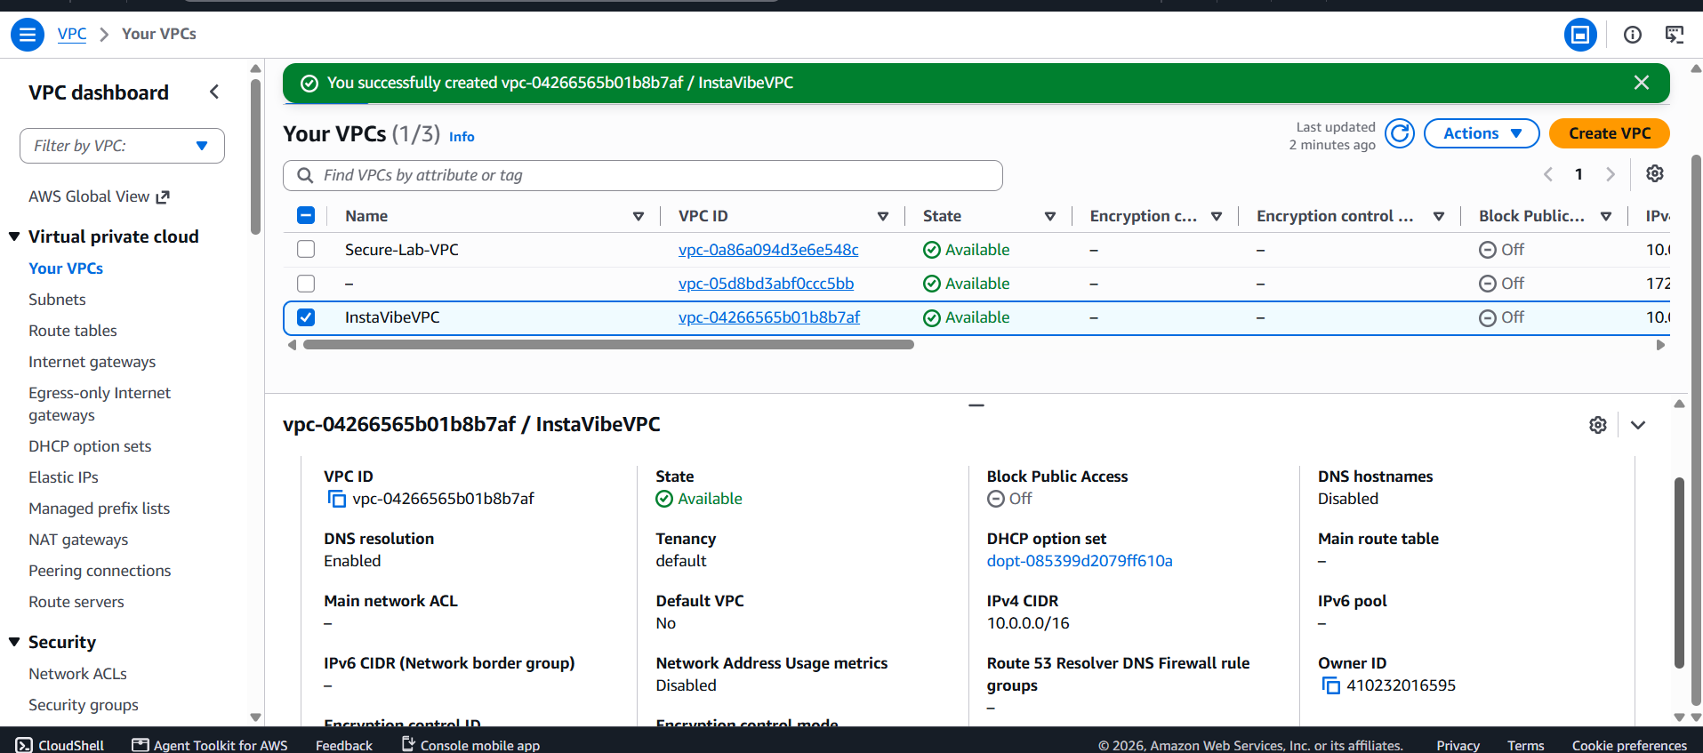
2.
Inside your InstaVibeVPC, create two subnets: one public subnet (e.g., 10.0.1.0/24) for hosting a web server and one private subnet (e.g., 10.0.2.0/24) for backend services.<br><br><em><strong>Hint:</strong> Name your subnets as 'PublicSubnet-Zomato' and 'PrivateSubnet-Zomato' for clarity.</em>
ANS :
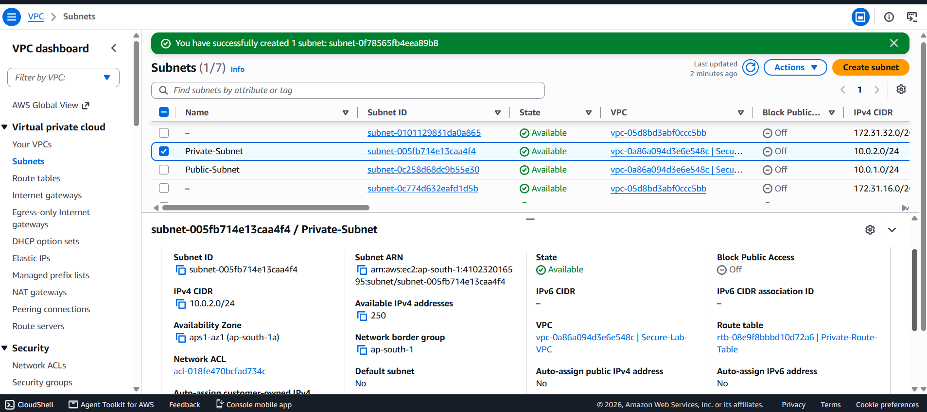
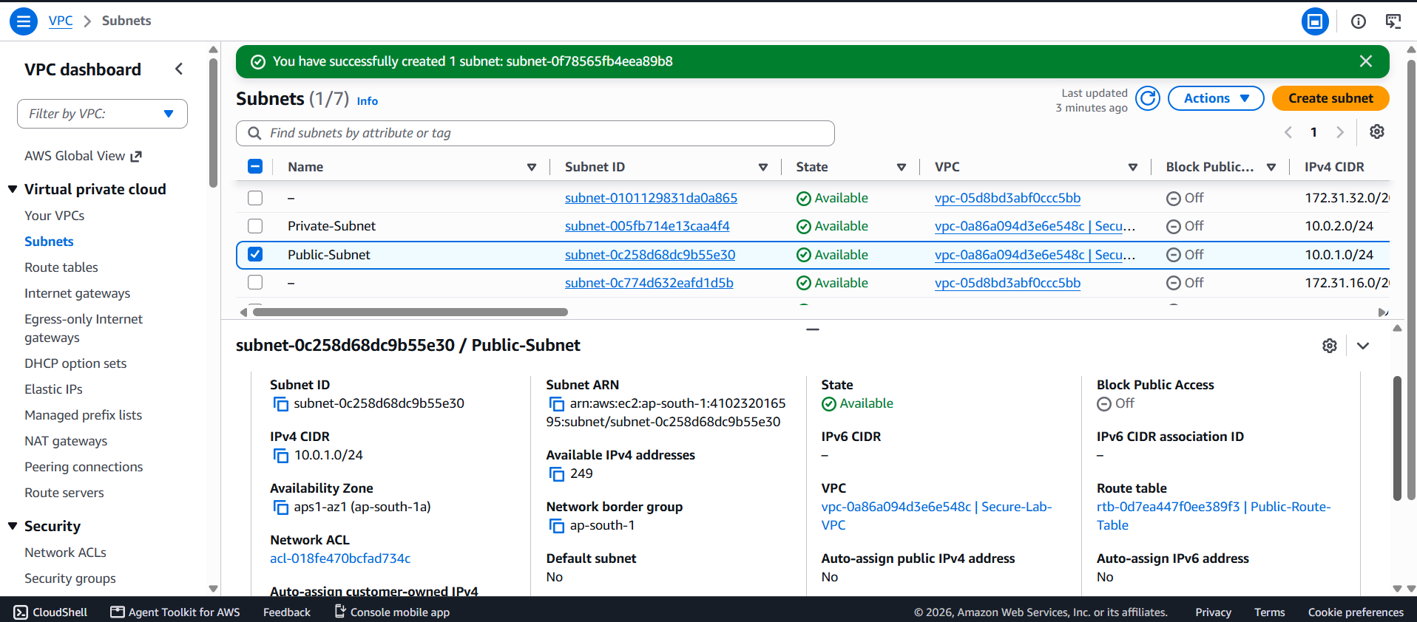
3.
Configure an Internet Gateway and attach it to your InstaVibeVPC so that only the public subnet can access the internet, while the private subnet cannot.
ANS :
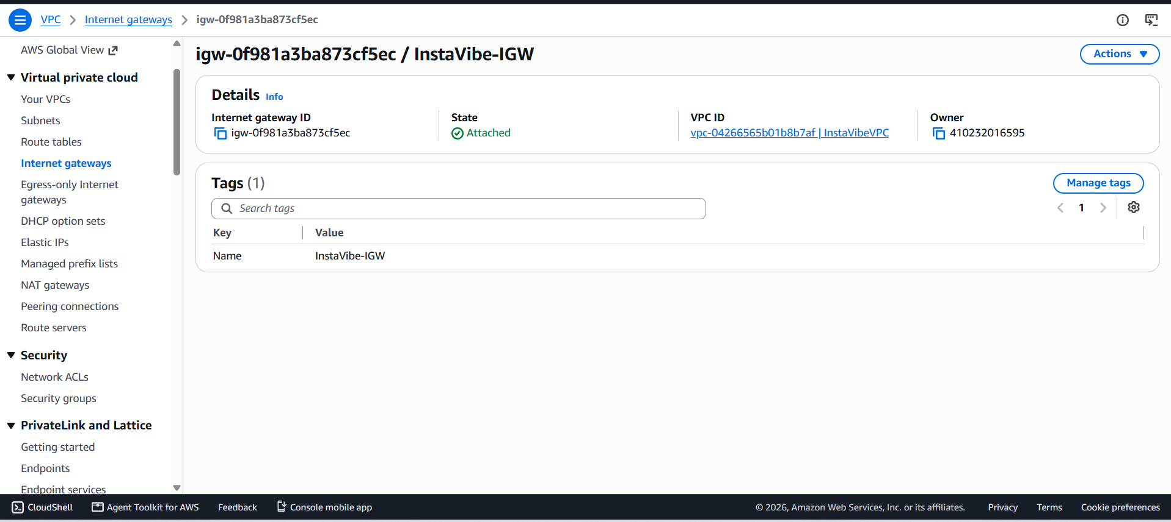
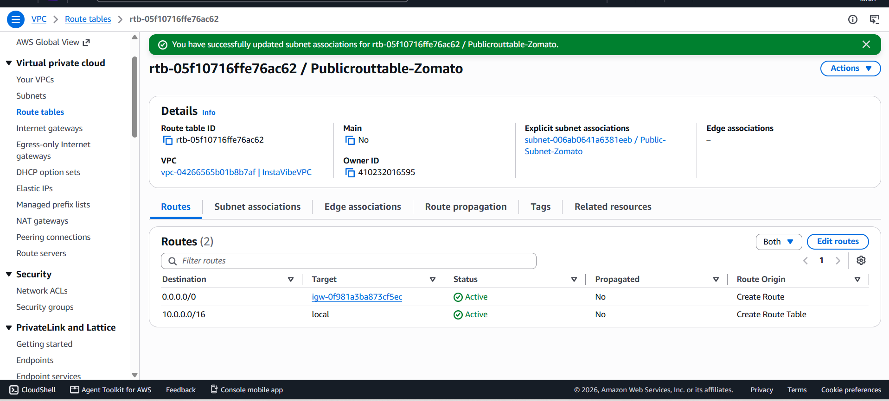
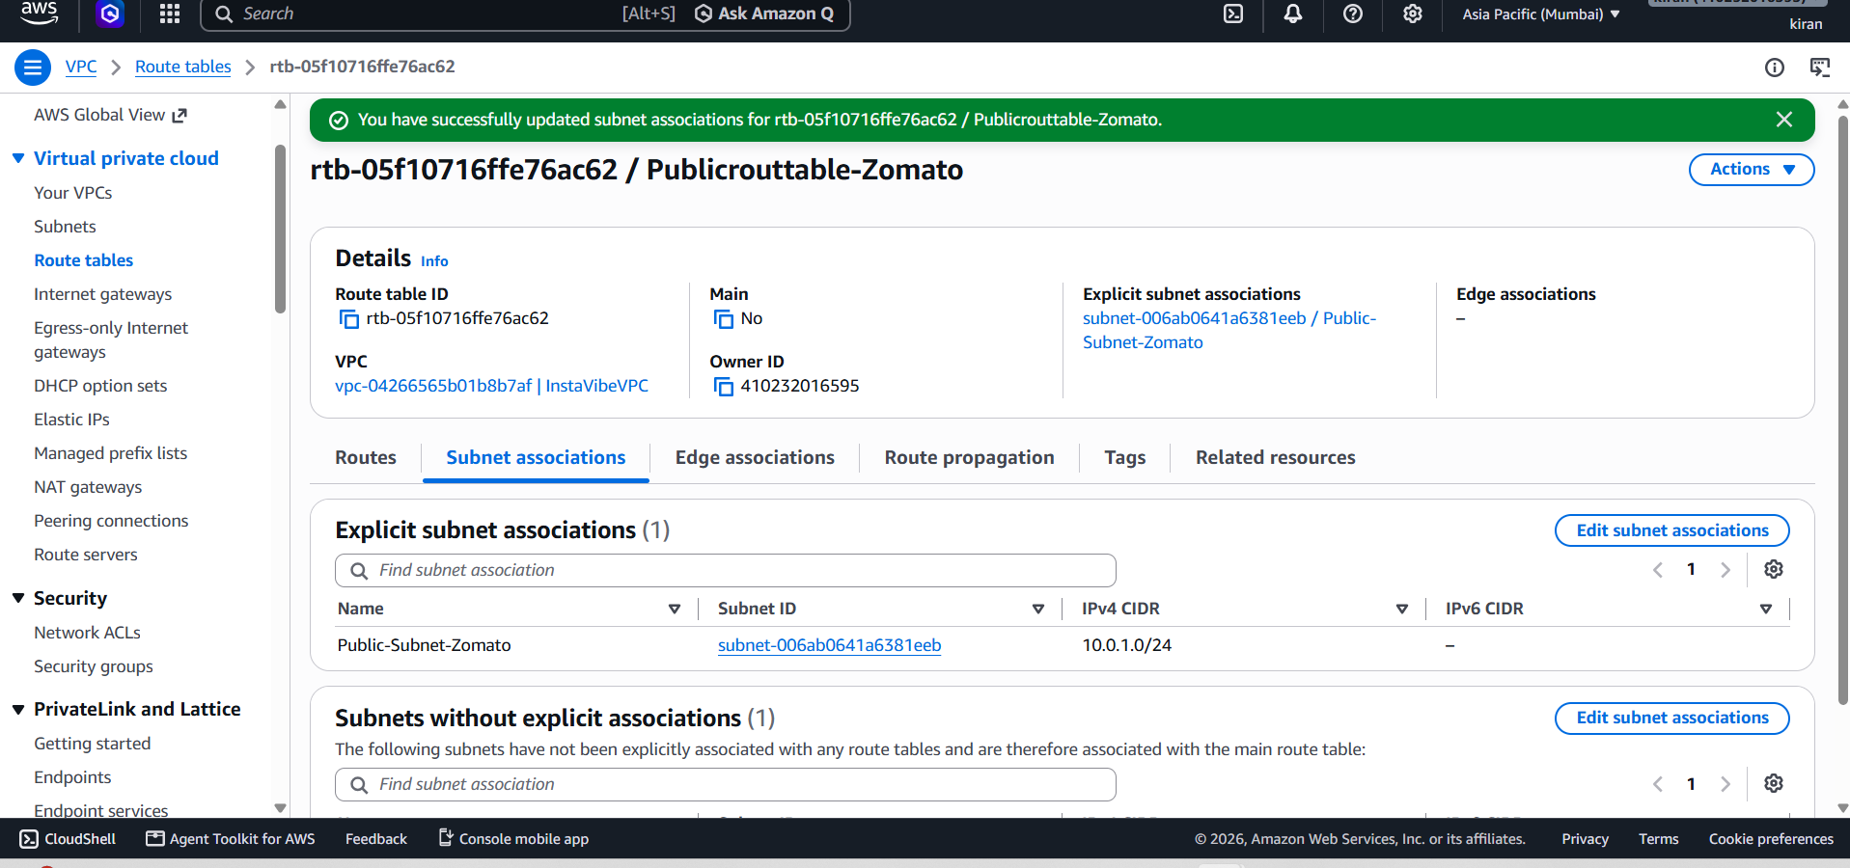
4.
Set up route tables so that your public subnet routes traffic to the Internet Gateway, but your private subnet does not. Verify this by checking the route table associations.
ANS :
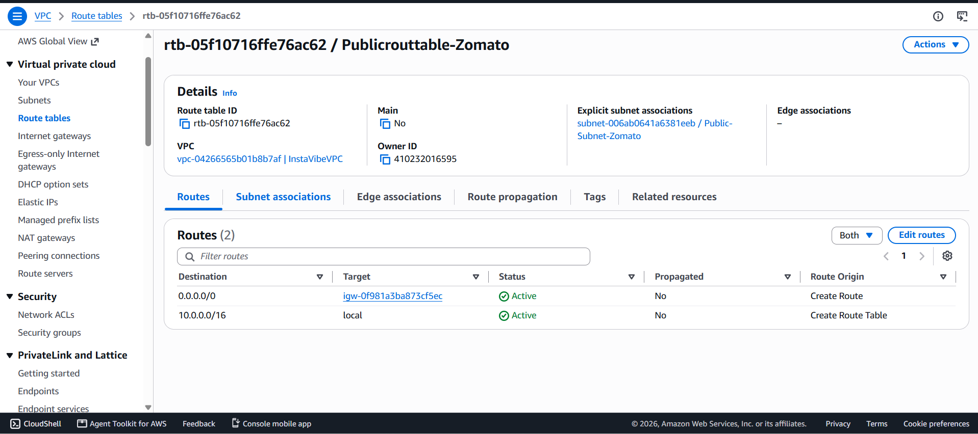
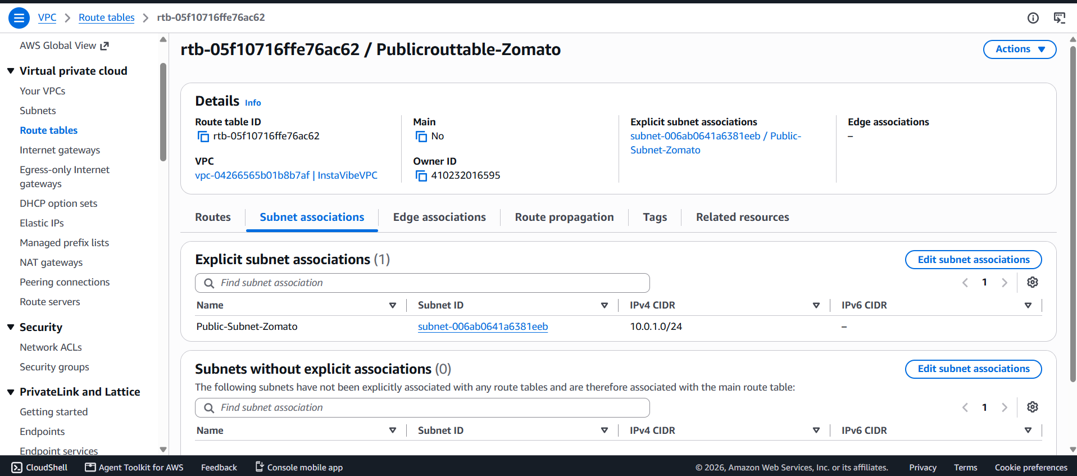
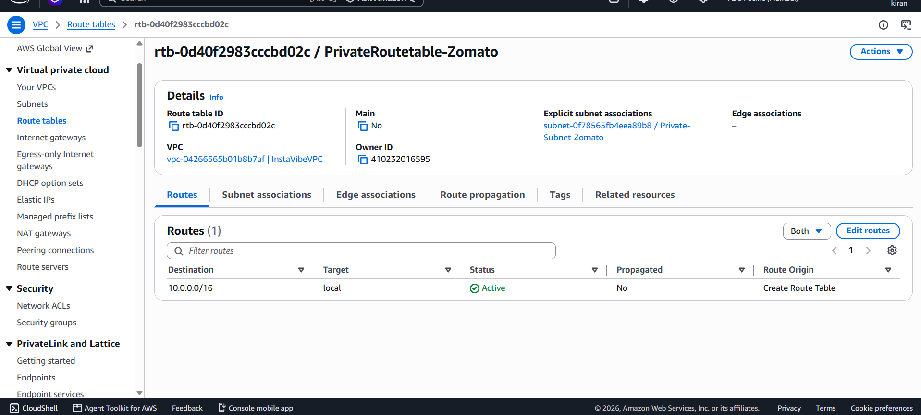
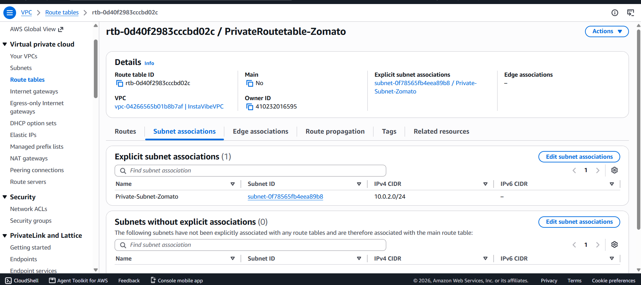
5.
Draw a simple diagram (hand-drawn or using any online tool) showing your VPC, public subnet, private subnet, and Internet Gateway, and briefly explain in 3-4 lines how this setup is similar to how apps like Zomato separate their public user interface from their private databases.
ANS :
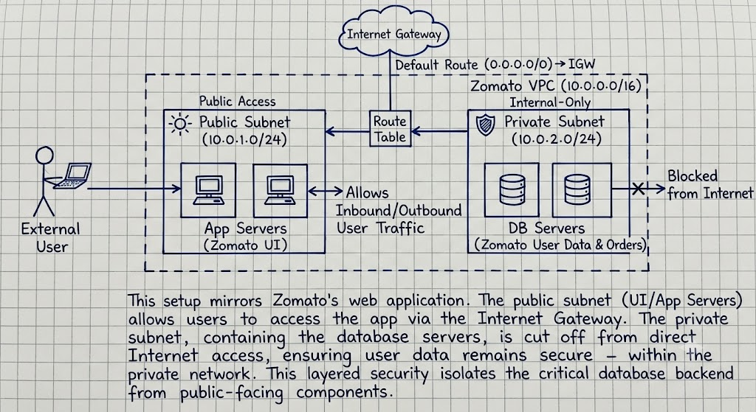
This VPC separates the public-facing web server from private backend services.
The public subnet can communicate with the Internet through the Internet Gateway.
The private subnet has no direct Internet Gateway route, keeping backend/database services protected.
This is similar to Zomato, where the user-facing application is separated from private databases and backend systems.

